**ASSIGNMENT 10**

Ria Mittal

322010

T.E. B - B1

Indexing and aggregation

> db.student.aggregate([{$group:{_id:"$dept",AGG:{$sum:"$age"}}}]);

{ "_id" : "it", "AGG" : 39 }

{ "_id" : "mech", "AGG" : 40 }

{ "_id" : "comp", "AGG" : 116 }

> db.student.aggregate([{$group:{_id:"$dept",AGG:{$max:"$age"}}}]);

{ "_id" : "it", "AGG" : 20 }

{ "_id" : "mech", "AGG" : 20 }

{ "_id" : "comp", "AGG" : 21 }

> db.student.aggregate([{$group:{_id:"$dept",AGG:{$min:"$age"}}}]);

{ "_id" : "it", "AGG" : 19 }

{ "_id" : "mech", "AGG" : 20 }

{ "_id" : "comp", "AGG" : 18 }

> db.student.aggregate([{$group:{_id:"$dept",AGG:{$sum:1}}}]);

{ "_id" : "it", "AGG" : 2 }

{ "_id" : "mech", "AGG" : 2 }

{ "_id" : "comp", "AGG" : 6 }

> db.student.aggregate([{$group:{_id:"$dept",AGG:{$avg:1}}}]);

{ "_id" : "it", "AGG" : 1 }

{ "_id" : "mech", "AGG" : 1 }

{ "_id" : "comp", "AGG" : 1 }

> db.student.aggregate([{$group:{_id:"$dept",AGG:{$avg:"$age"}}}]);

{ "_id" : "it", "AGG" : 19.5 }

{ "_id" : "mech", "AGG" : 20 }

{ "_id" : "comp", "AGG" : 19.333333333333332 }

> db.student.aggregate([{$group:{_id:"$dept",AGG:{$push:"$AGG"}}}]);

{ "_id" : "it", "AGG" : [ ] }

{ "_id" : "mech", "AGG" : [ ] }

{ "_id" : "comp", "AGG" : [ ] }

> db.student.aggregate([{$group:{_id:"$dept",AGG:{$first:"$age"}}}]);

{ "_id" : "it", "AGG" : 20 }

{ "_id" : "mech", "AGG" : 20 }

{ "_id" : "comp", "AGG" : 19 }

> db.student.aggregate([{$group:{_id:"$dept",AGG:{$last:"$age"}}}]);

{ "_id" : "it", "AGG" : 19 }

{ "_id" : "mech", "AGG" : 20 }

{ "_id" : "comp", "AGG" : 19 }

> db.student.aggregate([{$group:{_id:"$dept",AGG:{$addToSet:"$age"}}}]);

{ "_id" : "it", "AGG" : [ 19, 20 ] }

{ "_id" : "mech", "AGG" : [ 20 ] }

{ "_id" : "comp", "AGG" : [ 18, 21, 20, 19 ] }

> db.student.aggregate([{$group:{_id:"$dept",AGG:{$push:"$age"}}}]);

{ "_id" : "it", "AGG" : [ 20, 19 ] }

{ "_id" : "mech", "AGG" : [ 20, 20 ] }

{ "_id" : "comp", "AGG" : [ 19, 20, 19, 21, 18, 19 ] }

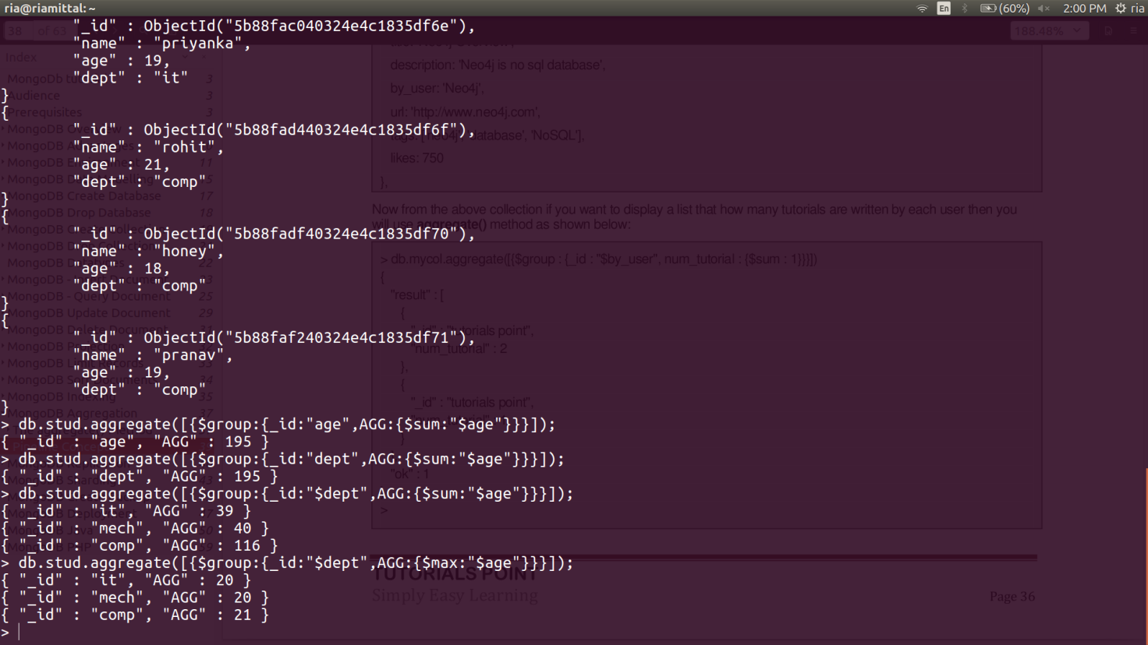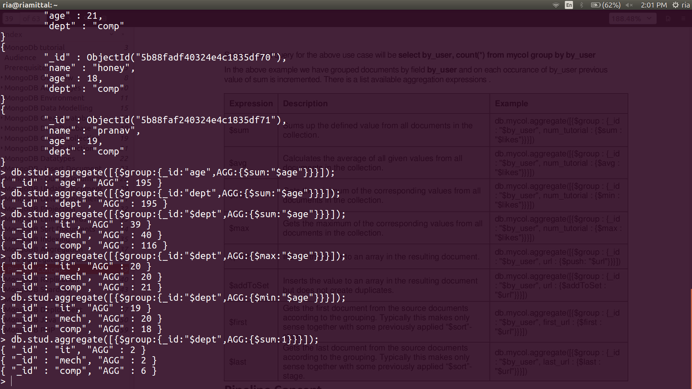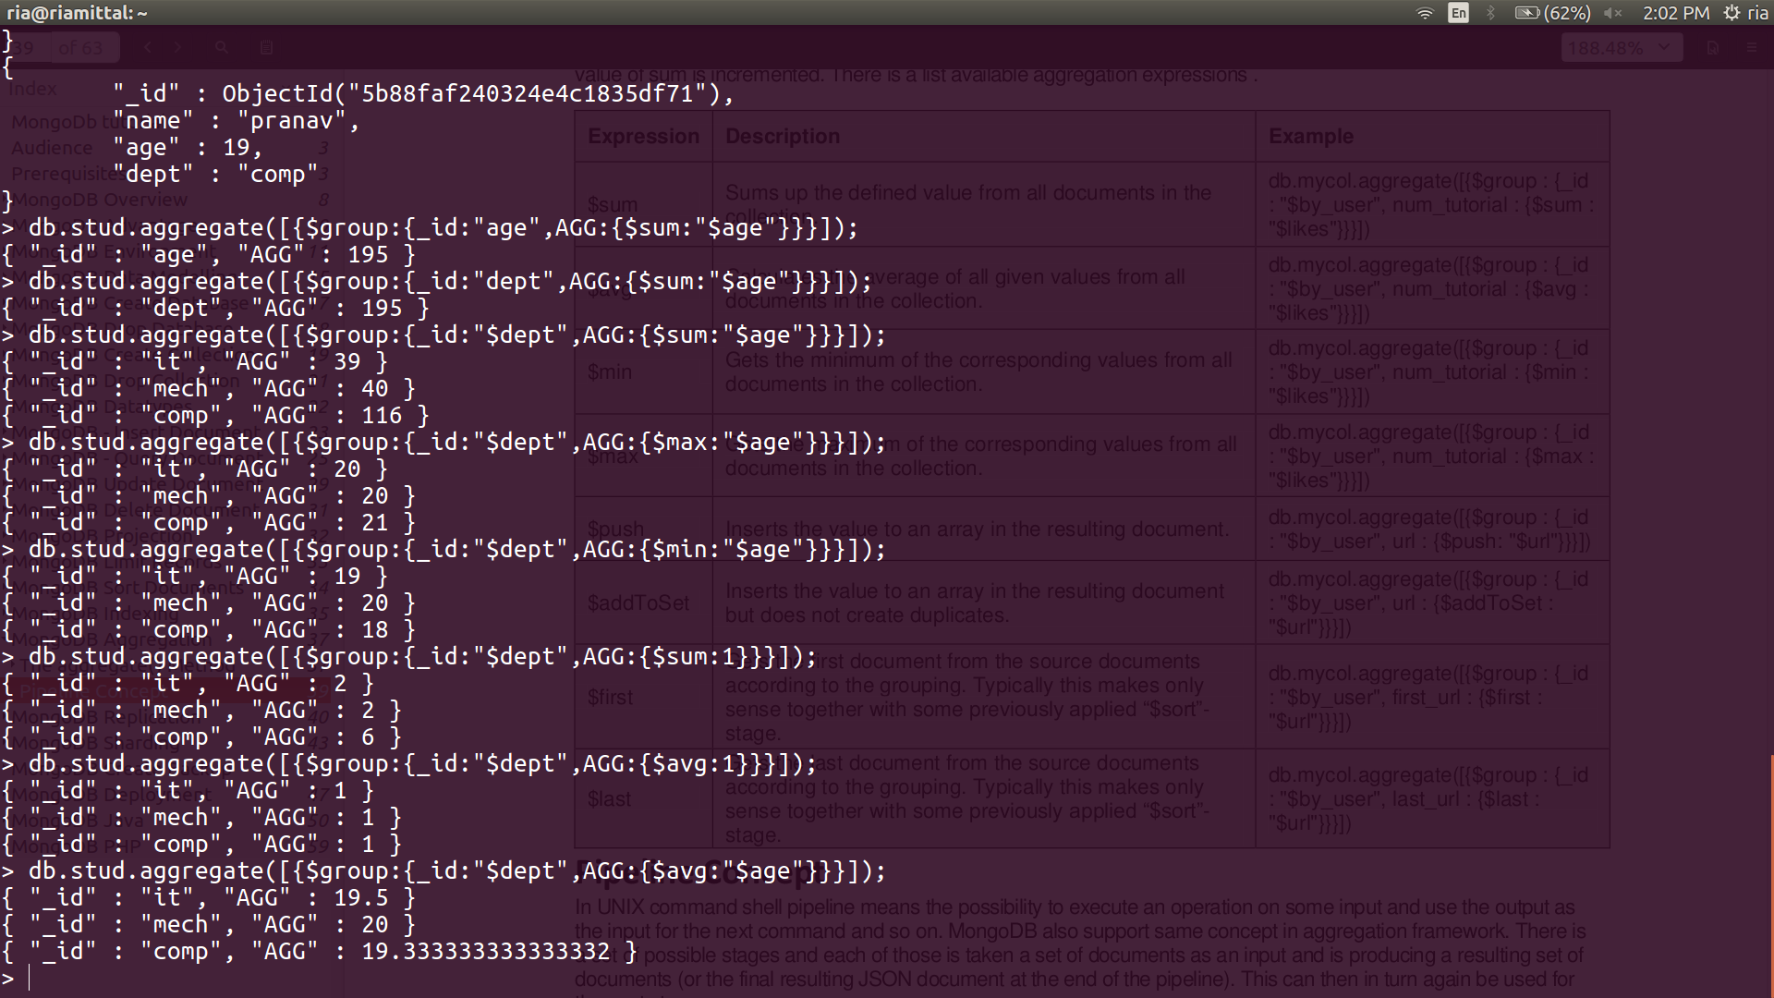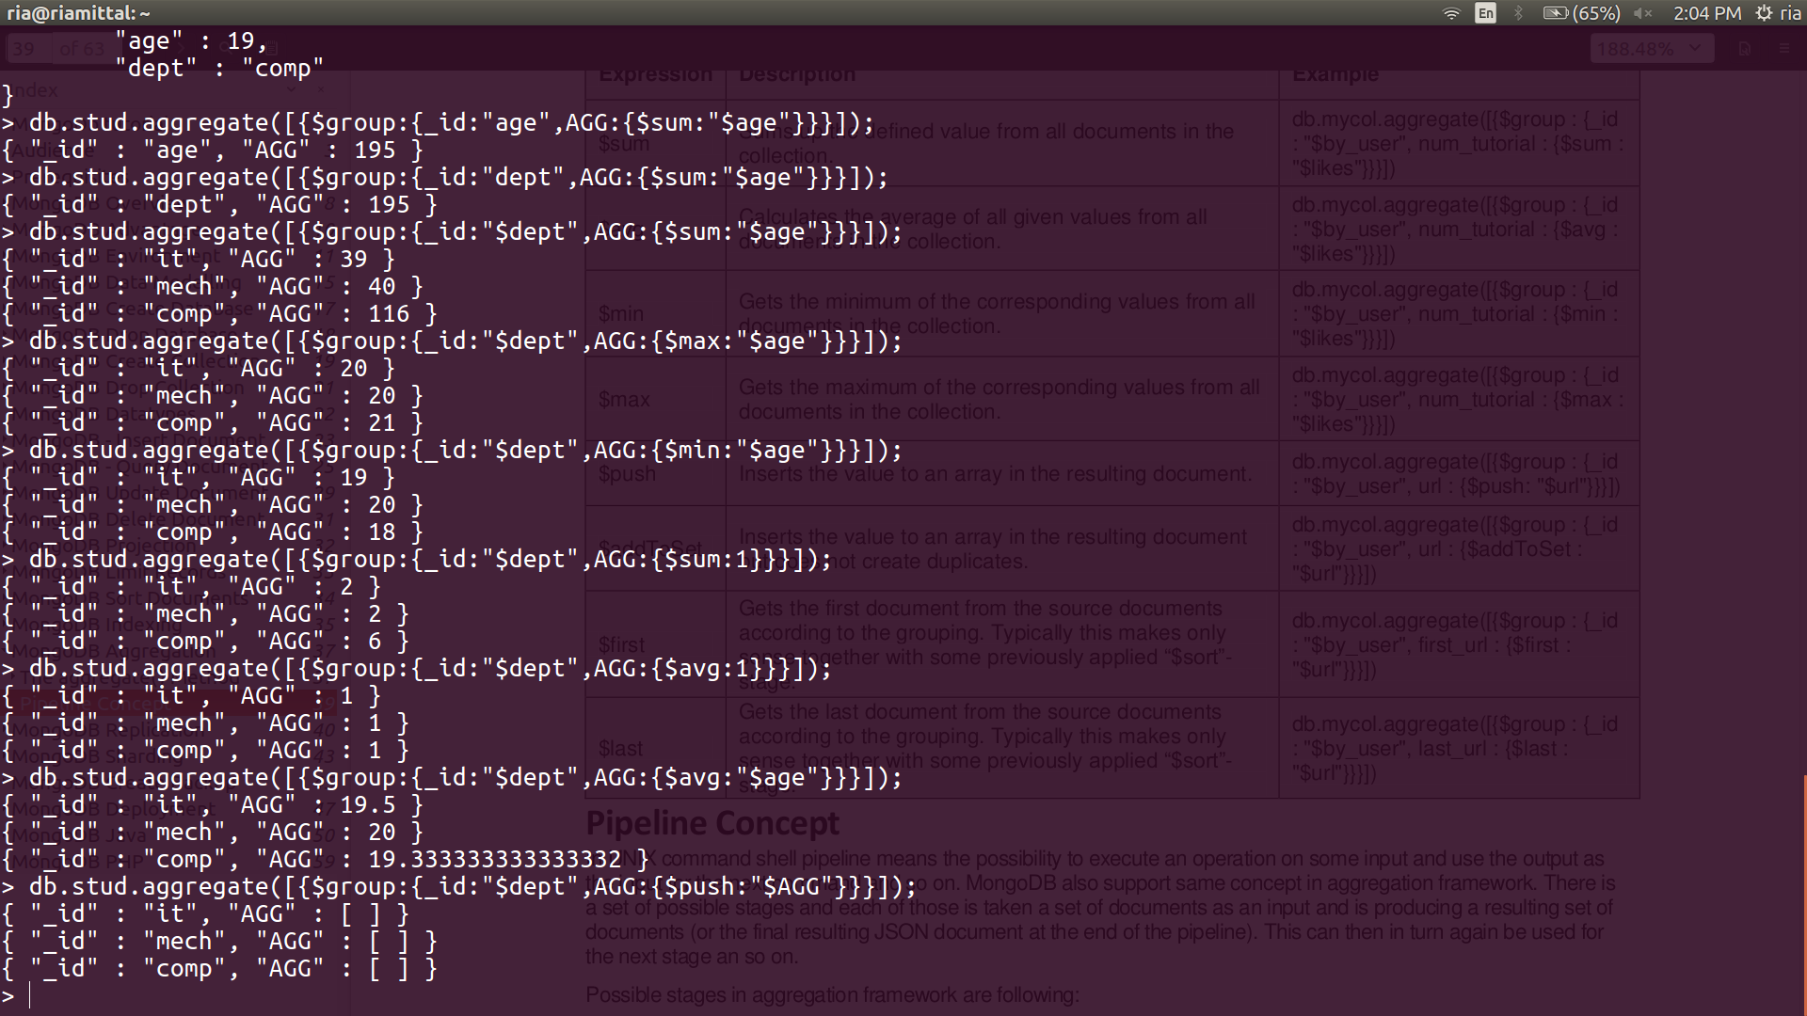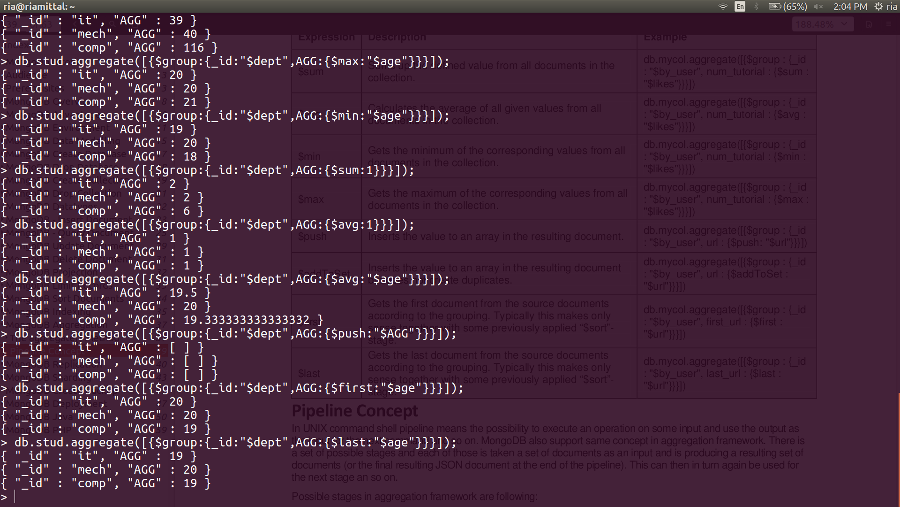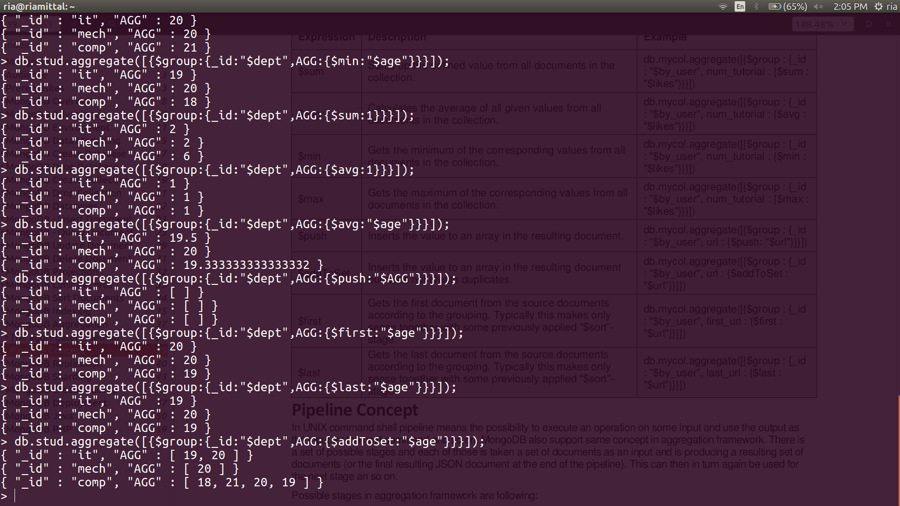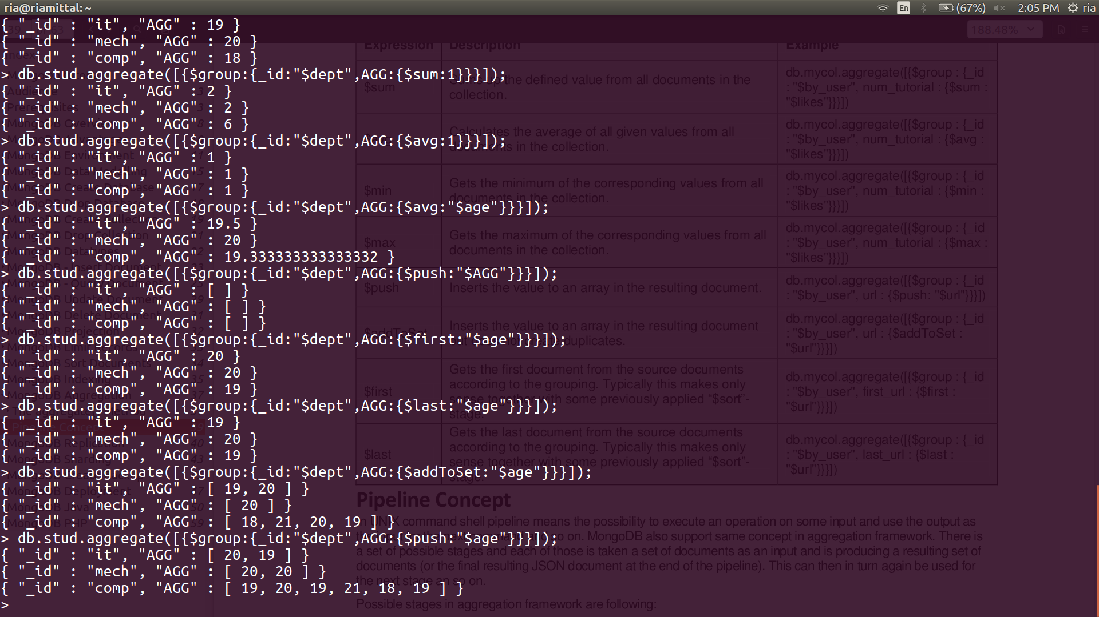

> db.student.ensureIndex({"age":1

... })

{

"createdCollectionAutomatically" : false,

"numIndexesBefore" : 1,

"numIndexesAfter" : 2,

"ok" : 1

}

> db.student.getIndexes();

[

{

"v" : 1,

"key" : {

"_id" : 1

},

"name" : "_id_",

"ns" : "ria.student"

},

{

"v" : 1,

"key" : {

"age" : 1

},

"name" : "age_1",

"ns" : "ria.student"

}

]

> db.student.aggregate([{$group:{_id:"dept",AGG:{$max:"$age"}}}]);

{ "_id" : "dept", "AGG" : 21 }

> db.student.aggregate([{$group:{_id:"dept",AGG:{$min:"$age"}}}]);

{ "_id" : "dept", "AGG" : 18 }

> db.student.aggregate([{$group:{_id:"dept",AGG:{$avg:"$age"}}}]);

{ "_id" : "dept", "AGG" : 19.5 }

> db.student.ensureIndex({"name":1 })

{

"createdCollectionAutomatically" : false,

"numIndexesBefore" : 1,

"numIndexesAfter" : 2,

"ok" : 1

}

> db.student.getIndexes();

[

{

"v" : 1,

"key" : {

"_id" : 1

},

"name" : "_id_",

"ns" : "ria.student"

},

{

"v" : 1,

"key" : {

"name" : 1

},

"name" : "name_1",

"ns" : "ria.student"

}

]

